Task 1: Develop an LED blinking application using the ESP32-S3 with a 1000 ms ON/OFF interval.
Components Required:
Hardware:
S.No | Component | Specification | Quantity
1 |  | ESP32-S3 DevKitC-1 | 1
  ESP32-S3
2 | LED | 5 mm | 1
3 |  |  | 1
  Resistor
  220 Ω or 330 Ω
4 | Breadboard |  | 1
  Standard
5 | Jumper Wires | Male-to-Female | 3-4
6 |  | USB 2.0/3.0 Data Cable | 1
  USB Type-C Data Cable
7 | Computer/Laptop | Windows 10/11 | 1
Software:
S.No | Software | Purpose
1 | Visual Studio Code  (VS Code) | Source code editor
2 |  | Project creation, build, upload, and debugging
  PlatformIO IDE Extension
3 | Arduino Framework | Provides libraries and APIs for ESP32-S3 programming
4 | ESP32 Platform Package (Espressif32) | Supports ESP32-S3 development in PlatformIO
5 | USB Serial Driver | Enables communication between the ESP32-S3 and the computer

Circuit Diagram:

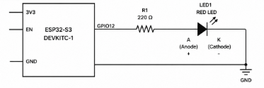
Flowchart:
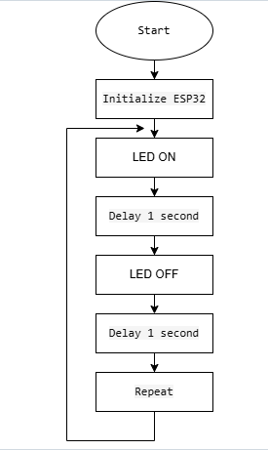
Code:
#includ <Arduino.h>
#define LED 12

void setup(){
pinMode(LED, OUTPUT);
}

void loop(){
digitalWrite(LED, HIGH);
delay(1000);
digitalWrite(LED, LOW);
delay(1000);
}

Test Result:

Test Item | Result
Hardware Connection | Pass
Code Compilation | Pass
Firmware Upload | Pass
LED ON Duration | 1000 ms
LED OFF Duration | 1000 ms
Continuous Blinking | Pass

Output:

